

Minutes of the Full Local Governing Body Meeting of Kirk Smeaton CE Primary School
held on Wednesday 6 May 2026 at 6:00 pm via TEAMS
Present: | Role | Time attended
Harvie Palmer (HP) | LA Governor | 6.00pm
Hannah Cuddy (HT) | Headteacher | 6.00pm
Carol Cessford (CC) | Foundation Governor | 6.00pm
Carol Ann Turner (CT) | Foundation Governor | 6.00pm
Katie Hallwood (KH) | Associate Governor | 6.00pm
Rebecca Rawson (RR) | Foundation Governor | 6.00pm
Sally Hammond (SH) | Parent Governor | 6.00pm
Jordanna Proctor (JP) | Co-opted Governor | 6.00pm
In attendance:
Helen Harris | AMF Clerk | 6.00pm

The meeting commenced at 6.10pm.

Colour coding Key
Blue – Approval/Decision taken
** Governor Challenge

Item | Minute
0. | Prayer and vision  The prayer and vision was shared at the meeting.
1. | Welcome, Introductions and Apologies  All governors introduced themselves.  Apologies for Absence and to determine whether any absences should be consented to.  – apologies accepted from Christian Brooks and Sadie Sheen.
2. | Appointment of Chair of Committee  HP was re-appointed as Chair of the Committee.
3. | Confidentiality and Declaration of Business Interests  All governors were aware of confidentiality and no additional declaration of business interests were declared.
4. | Any other business to be agreed  The Governors to discuss the staffing structure for September.
5. | To approve as a correct record, the minutes of the previous meeting  The confidential and non-confidential minutes of the Full and H&S Meeting held on 13 January 2026 were approved.  The confidential minutes were shared on the screen for Governors to view
6. | Action Log for Curriculum Committee  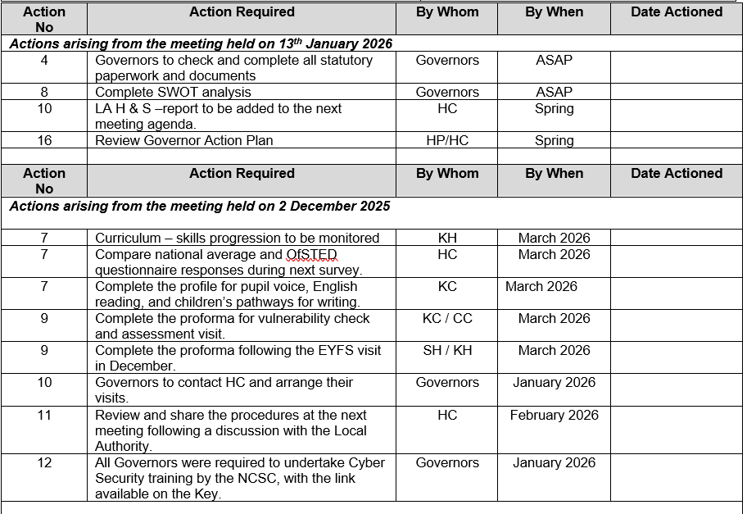  Actions from 13 January 2026 were completed.  Actions from 2 December 2025 had all been completed with the exception of item 7, comparison of national averages and OfSTED questionnaire responses. HC had reviewed national averages, but was unable to find anything specific; the completed questionnaires by OfSTED were positive. Governors would be presented with the outcome of the questionnaires. The HT is an OFSTED inspector and therefore sees parent voice at other schools and Kirk Smeaton Parent voice is positive in comparison. The profile for pupil voice required further clarification from KH, by HC.  Action: Profile for pupil voice (action 7) to be updated by HC.
7.  **  **  ** | Report from the Headteacher  The Headteacher’s report had been circulated in advance of this meeting. The main points to note are:  Safeguarding: See Confidential Minutes.  All governors have completed safeguarding and prevent training.  Health and Safety:  Governors noted the CCTV installation was completed. HP queried if there had been any near misses. HC advised there were none reported this term.  Governor Roles and Responsibilities:  Governors reviewed their roles and responsibilities. Staff had been advised to speak to Governors directly through various communication channels. Governors were asked to review the roles and responsibilities list, would receive anonymised class reports and Governors would provide support and challenge to staff. Action plans would be shared by staff to aid Governors. HP requested Governors to review the list and asked HC to feedback to staff.  Visits in School:  HC explained visits had included an Inclusion day, health and safety meeting and year 6 access arrangements.  Attendance:  HC explained the attendance data for September-March 2025 would be shared with Governors, it was above national but would be impacted due to some children missing education.  Accident and Attitudes:  HC explained there had been no positive handling and no exclusions. There were no specific trends but there would be two referrals to provide support to parents.  H&S Checks  HC explained January – March 2026 there had been some near misses, which had been shared with staff and providers. The Caretaker commences at the start of the day which had resulted in a WhatsApp group being created to ensure everyone was aware. The last person to leave closes doors and locks windows. HP queried whether there were any near misses due to the Eagles door. HC explained there were no specific trends having reviewed the accident book, any specific health and safety risks would be reviewed and trends would be identified with pupils having accidents.  Action: Attendance data to be shared with Governors for September-March 2026 by HC.  Action: HP requested Governors to review the list and asked HC to feedback to staff.
8.  ** | Academisation  HC and HP had emailed Adam who was currently pursuing academisation. HP stated there were no further updates. Staff and Governors had reviewed the SWOT Analysis. Staff and parents would be communicated should a formal process commence.
9. | Partnership Agreement with Leger  HC explained a meeting was to be held with Adam in one weeks’ time, the letter had been submitted to the Diocese and updates would be shared with Governors in due process.
10. | Mid Year PM for HC  HC explained a date would be arranged for September. HC and HP to meet and discuss further options.  Action: HC and HP to discuss Mid-Year PM
11.  **  **  ** | Business Case Plans  Sports Package: HC explained the school was working with Leger who had created their own sports programme and was inclusive event-based and not competition based. Leger does not have a specific package. Activate charges £7.5K for a similar package. Packages were for morning sessions which could be provided for children and parents. Legacy costs were more expensive and did more internal competitions, with kids being in an active competition. A discussion would be held with Activate to understand their packages and the link with Legacy. Feedback from staff was not positive with Leger and wished to continue with Legacy as they organise school buses.  RR queried whether this was a decision for Governors, whether this was a cost and quality issue? HC explained the information was shared for due diligence, the school would continue with Legacy. The school had not been provided with a clear breakdown of costs, with some providers including dinner depending upon capacity. RR recommended HC to request pricing for a full package. HP stated there was a requirement to have a like-for-like comparison. HC agreed to investigate and seek clarification on the types of packages with Leger and Excite. Legacy provide after school provision, parents engage with this, pupils undertake a variety of clubs, there was a high level of take-up which was positive and it supported the school with wraparound care. RR stated as a group there is a level of accountability to ensure public money is wisely spent and the school were receiving value for money. HC was required to provide details to Legacy by 31 May 2026 and this would be discussed at a future meeting.  Kitchen Business Case Plan: HC explained quotes were outstanding.  Action: HC to investigate costs with Legacy and Excite and present to Governors at a future meeting.
12.  ** | School Updates  Cawood:  HC was attending Cawood two days a week, staff were doing a good job, the inspection was last week and good practice had been highlighted. HP queried the workload. HC explained it was being managed. HP questioned if any aspects required Local Authority support. HC had appointed two teachers and areas were being delegated to other leaders within the school.  OfSTED:  The inspection was last week.  ESP with the Diocese:  HC explained SIAMS inspection was September 2025 and there would be a cost saving if should the school not sign up? HP queried whether the school was in scope and RR asked if there was any benefit considering the changes in governance. HC recommended the school opt-in to the process. HP stated the cost was within HC’s delegated limit. All Governors agreed to stay in SIAMS.  Action: HC to ensure the school retains SIAMs.
13.  **  ** | Communications with Stakeholders  - Forest school sleep over for Year 3/4. HP questioned whether risk assessments had been completed, what was the highest risk and mitigations. HC explained the risk was access to the site, gates would be locked and the hall would be unlocked. The fire service and police had been notified to ensure safety within the community. HC would be oncall. If there was torrential rain the hall would be utilised. HP queried whether medical needs had been accounted for. HC explained a defib and medication would be provided and parents would sign a confirmation.  - PHSE consultation had been sent to parents and would be shared with Governors at the next meeting.  - White paper consultation. Governors were able to provide their own feedback to the consultation.  - Platinum award for Healthy schools had been awarded to the school. All staff were thanked.  Action: HC to share the PHSE Consultation at the next meeting.
14. | 3 year plan- sustainability and capacity  - Academisation was discussed earlier in the agenda.  - Staffing was to be discussed under Any Other Business  - Budget was presented to Governors and were to provide questions to the Chief Finance Officer.  - Pupil numbers for reception were approximately 11 / 12, one boy may be home-schooled but this was being discussed with the parent. Some children had looked around the school to determine if they wished to attend, rather than being home-schooled.
15. | Meetings in school with external agencies  - English hub report  - Helen Lever Diocese report  - Aishling Robinson- English report
16. | Staffing and governors  Parent Governor – Christian had been appointed as parent governor.
17. | Governor Action Plan and gov monitoring  Dates for monitoring and dates to be aware of for next term are:  HC advised the summer fair was yet to be decided.  WC 4.5.26- Finance , IT (360 meeting), PE monitoring and playtime monitoring and PD  WC 11.5.26- SATS week, reviewing all daily readers. 15th May Aishling Robinson (LA) in school to look at writing in school- governor needed to support.  WC 18.5.26- 18th May Leger to come and do a T&L review all day. Governor needed to support. Music monitoring.  WC 1.6.26- MTC testing for 2 weeks. PHSE and RE monitoring  WC 8.6.26- Phonics testing for 2 weeks. Eagles will be getting reading for the Art display- this would be good to see the art showcase. 11th June- career morning (TBC)  WC 15.6.26- 15th June- Leger to do a safeguarding review at Kirk Smeaton- governor needed to support. MFL, Science and Humanities check ins- there will be handover meetings with Sarah, Megan and Katie. Sports day on 19th June and if it rains it will move to 3rd July.  WC 22.6.26- Maths monitoring- this will include meeting with Hannah and Rachel to look at next steps and handover work for next year. 25th June School sleepover for Lions class.  WC 29.6.26- Council summit happening this week. Pupil progress meetings- assessment. Subject ambassadors updates.  WC 6.7.26- Reports to go out. SATS result 7th July. Transition morning 9th July.  WC 13.7.26- Final week. Church for the leavers on 16th July at 9am.  Changes in subject leadership will happen in Sept, but handover will happen this term.
18. | Health and safety  Governors were advised of the following health and safety matters:  - School sleepover  - Robinwood- first date after September 2026  - Trip to Gurdwara and Mosque, dates for KS2 to attend were being agreed.
19. | Governor monitoring.  - Link governor responsibilities and succession planning was reviewed.  - Governor action plan was to be reviewed by Governors.  - Governor training log was to be reviewed by Governors.  - Assessment meeting with KH and governors was held in March and another meeting would be arranged for July.  - Carol Ann’s visit was undertaken in April 2026, the report had been included on Sharepoint.  - Safeguarding meeting was held between JP and HP in April 2026, the report had been included on Sharepoint.  Action: Governors to review the link governor responsibilities, action plan and training log.
20. | Governor training and any paperwork to be signed.  Governors to complete the online training log.  Action: Governors to complete the training log.
21.  ** | Policies  HC advised the PHSE was under consultation.  Governors approved the following policies:  - Budget management policy  - Allergen’s policy  CT queried whether there was a requirement for a deputy allergen lead due to Benedicts law. HC would add a Deputy to the Allergen Policy.  Action: HC to add a Deputy to the Allergen Policy.
22. | Safeguarding  Governors were asked to review the Safeguarding meeting notes.  Action: Governors to review the Safeguarding meeting notes.  KH left the meeting at 6.55pm
23. | Any Other Business  Staffing: see Confidential Minutes.  HC left the meeting at 7.02pm.
24. | How has this meeting impacted on the welfare and progress of our pupils?  Governors agreed that the meeting had impacted on health and safety, safeguarding and business case plans.
25. | Date of Next meeting(s)  Curriculum meeting, July 2026.
Meeting closed at 7.04pm
Chairperson to approve and sign off the minutes as a true record
(This is not to be signed until governors’ approval at the next meeting)

Action  No | Action Required | By Whom | By When | Date Actioned
Actions arising from the meeting held on 6 May 2026

6 | Profile for pupil voice (action 7) to be updated. | HC | 16/5/2026
7 | Attendance data to be shared with Governors for September-December 2025. | HC | 16/5/2026
10 | Discuss Mid-Year PM | HC/HP | 31/7/2026
11 | Investigate costs with Legacy and Excite and present to Governors at a future meeting. | HC | 30/6/2026
12 | Ensure the school retains SIAMs | HC | 31/5/2026
13 | Share the PHSE Consultation at the next meeting | HC | 315/2026
19 | Governor Monitoring: review the link governor responsibilities, action plan and training log | Governors | 31/5/2026
20 | Governor Training: complete the online training log | Governors | 31/5/2026
21 | Add a Deputy to the Allergen Policy | HC | 31/5/2026
Action  No | Action Required | By Whom | By When | Date Actioned
Actions arising from the meeting held on 13 January 2026

4 | Governors to check and complete all statutory paperwork and documents | Governors | ASAP | Complete
8 | Complete SWOT Analysis | Governors | ASAP | Complete
10 | LA H&S report to be added to the next meeting agenda | HC | Spring | Complete
16 | Review Governor Action Plan | HP/HC | Spring | Complete
Action  No | Action Required | By Whom | By When | Date Actioned
Actions arising from the meeting held on 2 December 2025

7 | Curriculum – skills progression to be monitored | KH | March 2026 | Complete
7 | Compare national average and OfSTED questionnaire responses during next survey. | HC | March 2026 | Complete
7 | Complete the profile for pupil voice, English reading, and children’s pathways for writing. | KC | March 2026
9 | Complete the proforma for vulnerability check and assessment visit. | KC / CC | March 2026 | Complete
9 | Complete the proforma following the EYFS visit in December. | SH / KH | March 2026 | Complete
10 | Governors to contact HC and arrange their visits. | Governors | January 2026 | Complete
11 | Review and share the procedures at the next meeting following a discussion with the Local Authority. | HC | February 2026 | Complete
12 | All Governors were required to undertake Cyber Security training by the NCSC, with the link available on the Key. | Governors | January 2026 | Complete

